**SRI SIDDHARTHA DENTAL COLLEGE**

**STAFF AND STUDENT WELFARE COMMITTEE**

**Personality and Professional development**

Professional growth is all about gaining new skills and experiences. That means development is either related to current role or role we undertake next.

Personal development fits alongside professional growth. So if we want to progress in our career we need to develop personally first.

**SRI SIDDHARTHA DENTAL COLLEGE**

**STAFF AND STUDENT WELFARE COMMITTEE**

**Name of the capability enhancement and skill development scheme: Personality and Professional development (Topic: Cashless transactions)**

**Year of implementation: 2016**

**Number of students enrolled:**

**Name of the agencies involved with contact details: Mr Arun Narayan, Director UK-India business council, Bangalore.**

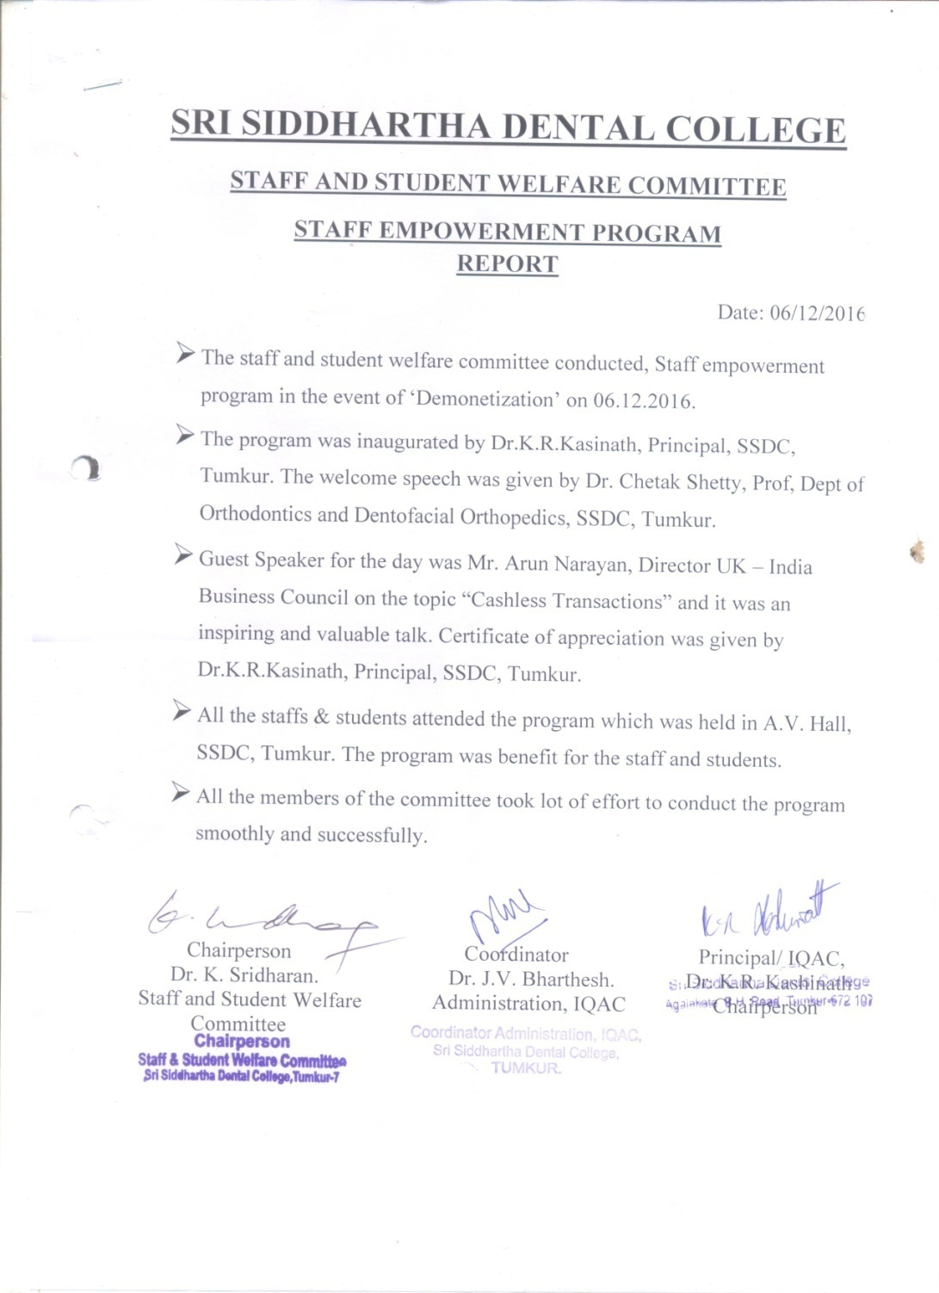

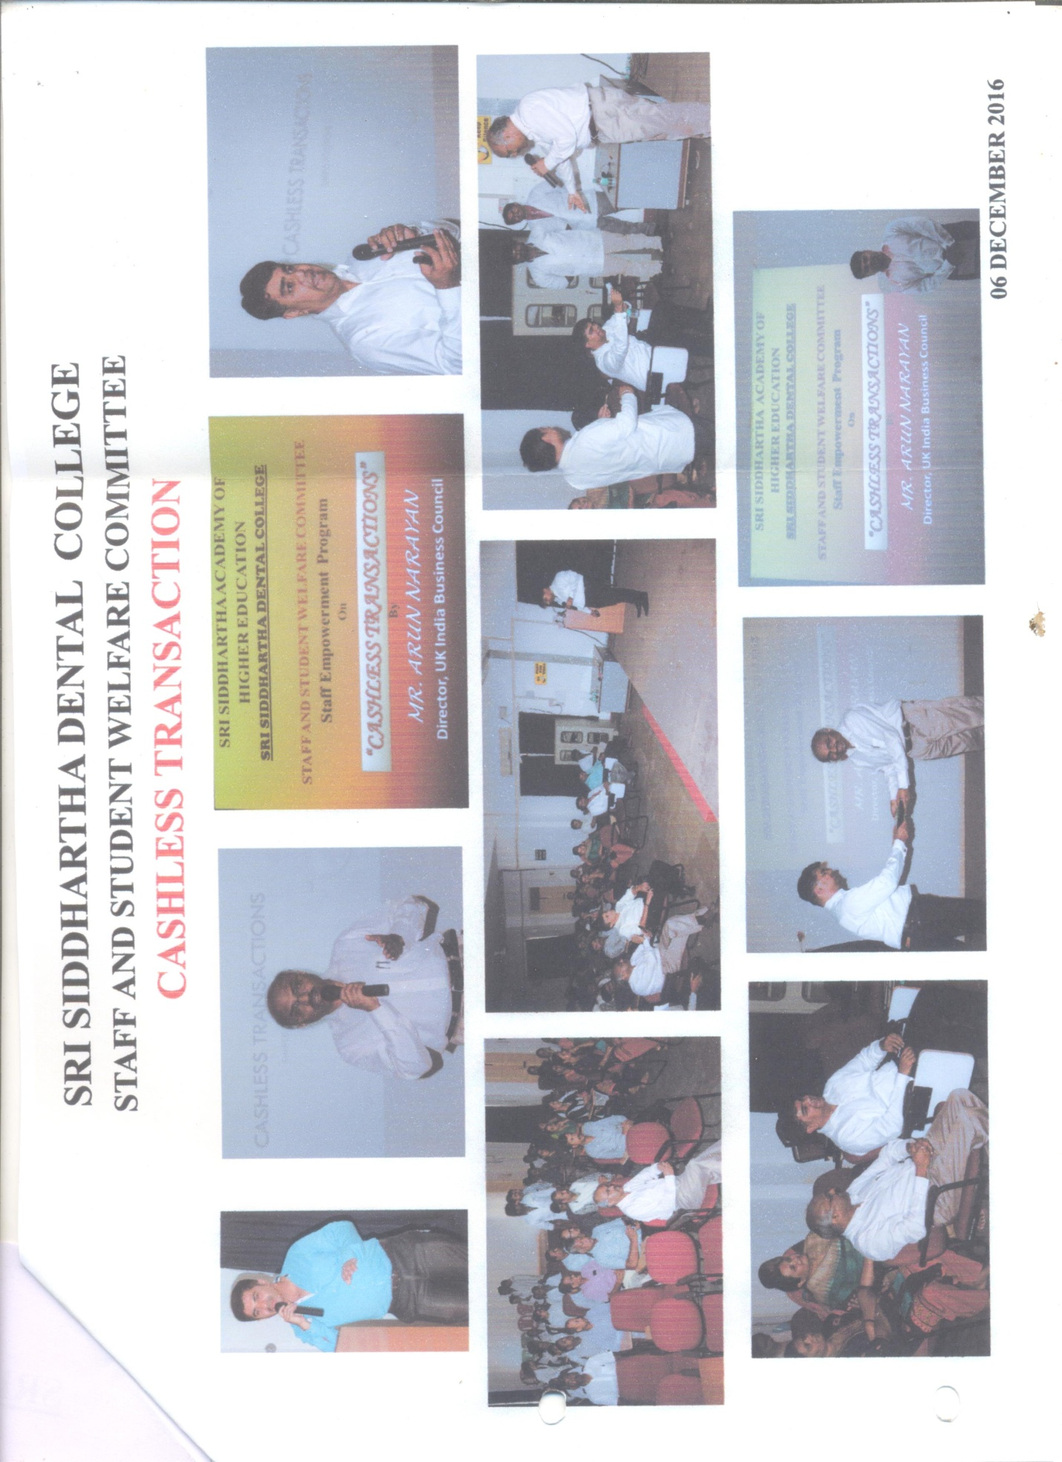

**Name of the capability enhancement and skill development scheme: Personality and Professional development (Topic: Research in dental sciences)**

**Year of implementation: 2020**

**Number of students enrolled:**

**Name of the agencies involved with contact details: Dr. Ramesh Chowdhary, Head Dept of Research, Rajarajeshwari Dental college, Bangalore & Dr Shivaprasad B M, Prof Dept of Periodontics, Rajarajeshwari Dental college, Bangalore**



